
EXPERIMENT – 13



Ai
m
To create a Virtual Machine with 1 CPU, 2GB RAM, and 15GB storage using a Type-2 virtualization software (VMware Workstation).


Procedure
- Launch VMware Workstation Player or Pro on your host operating system.
- Click on 'Create a New Virtual Machine'.
- Select 'Installer disc image file (iso)' and browse to select your guest OS ISO file (e.g., Ubuntu or Windows).
- Choose the guest operating system type and version (e.g., Linux > Ubuntu 64-bit).
- Provide a name for the virtual machine and select the storage location.
- Set the disk size to 15 GB and choose 'Store virtual disk as a single file'.
- Click on 'Customize Hardware' and adjust the settings:
  - Memory: 2048 MB (2 GB)
  - Processors: 1 core
  - Ensure the network adapter is set to NAT or Bridged.
- Click 'Close' to save the hardware configuration, then click 'Finish' to create the virtual machine.
- Start the virtual machine and proceed with the installation of the selected operating system.

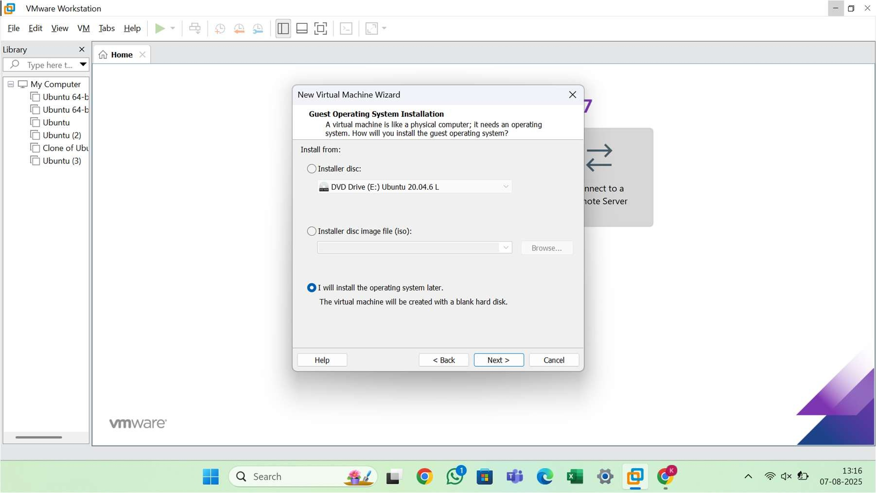
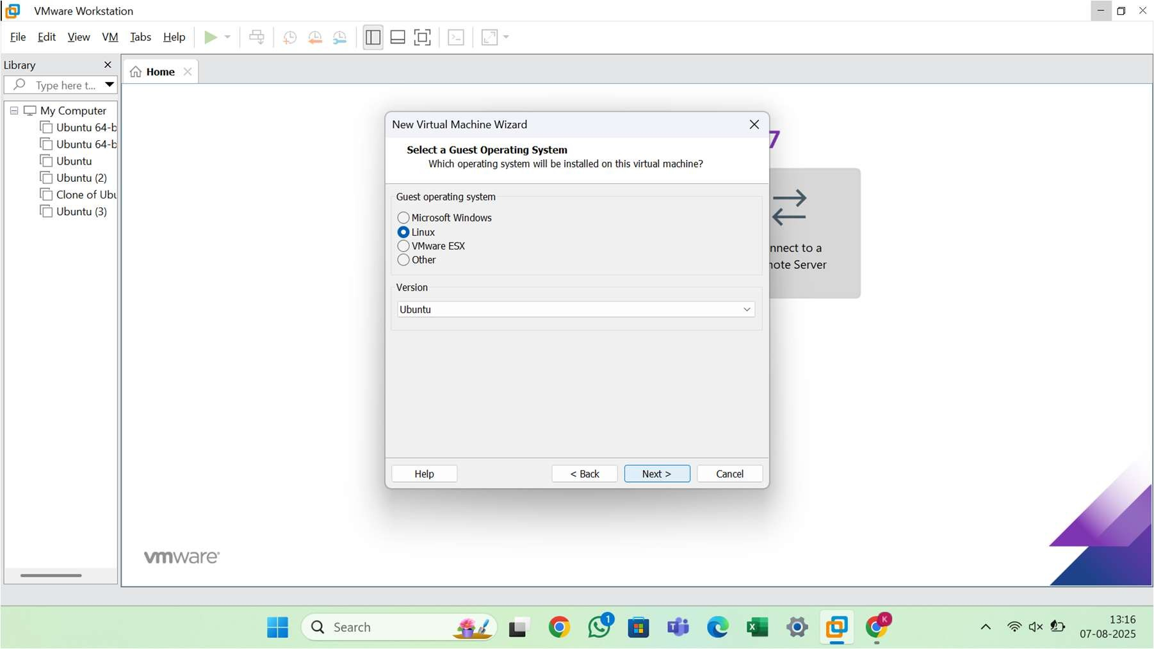

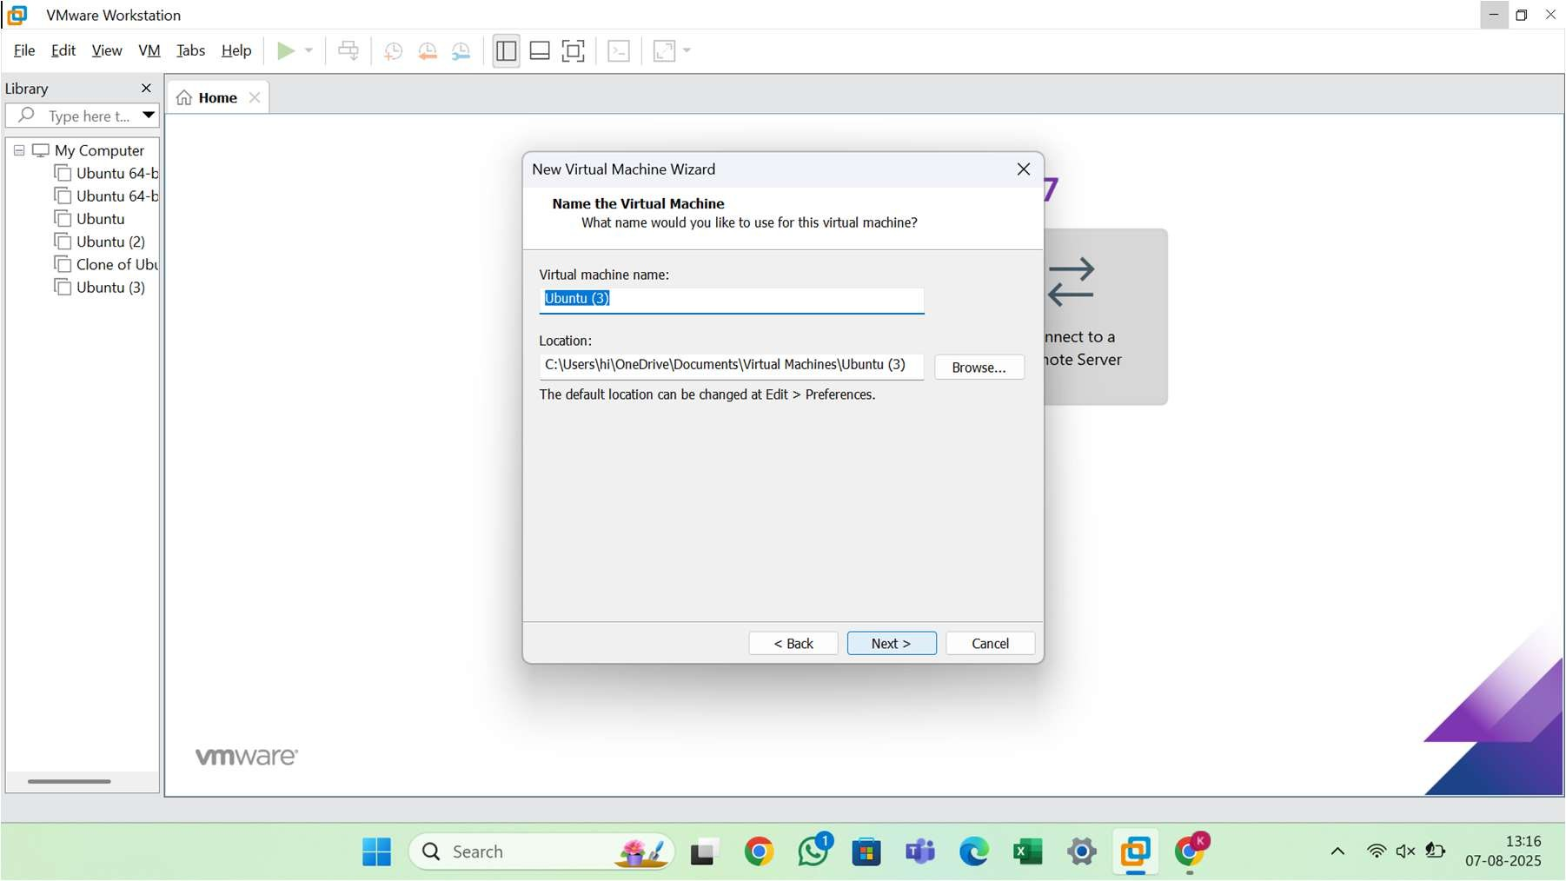

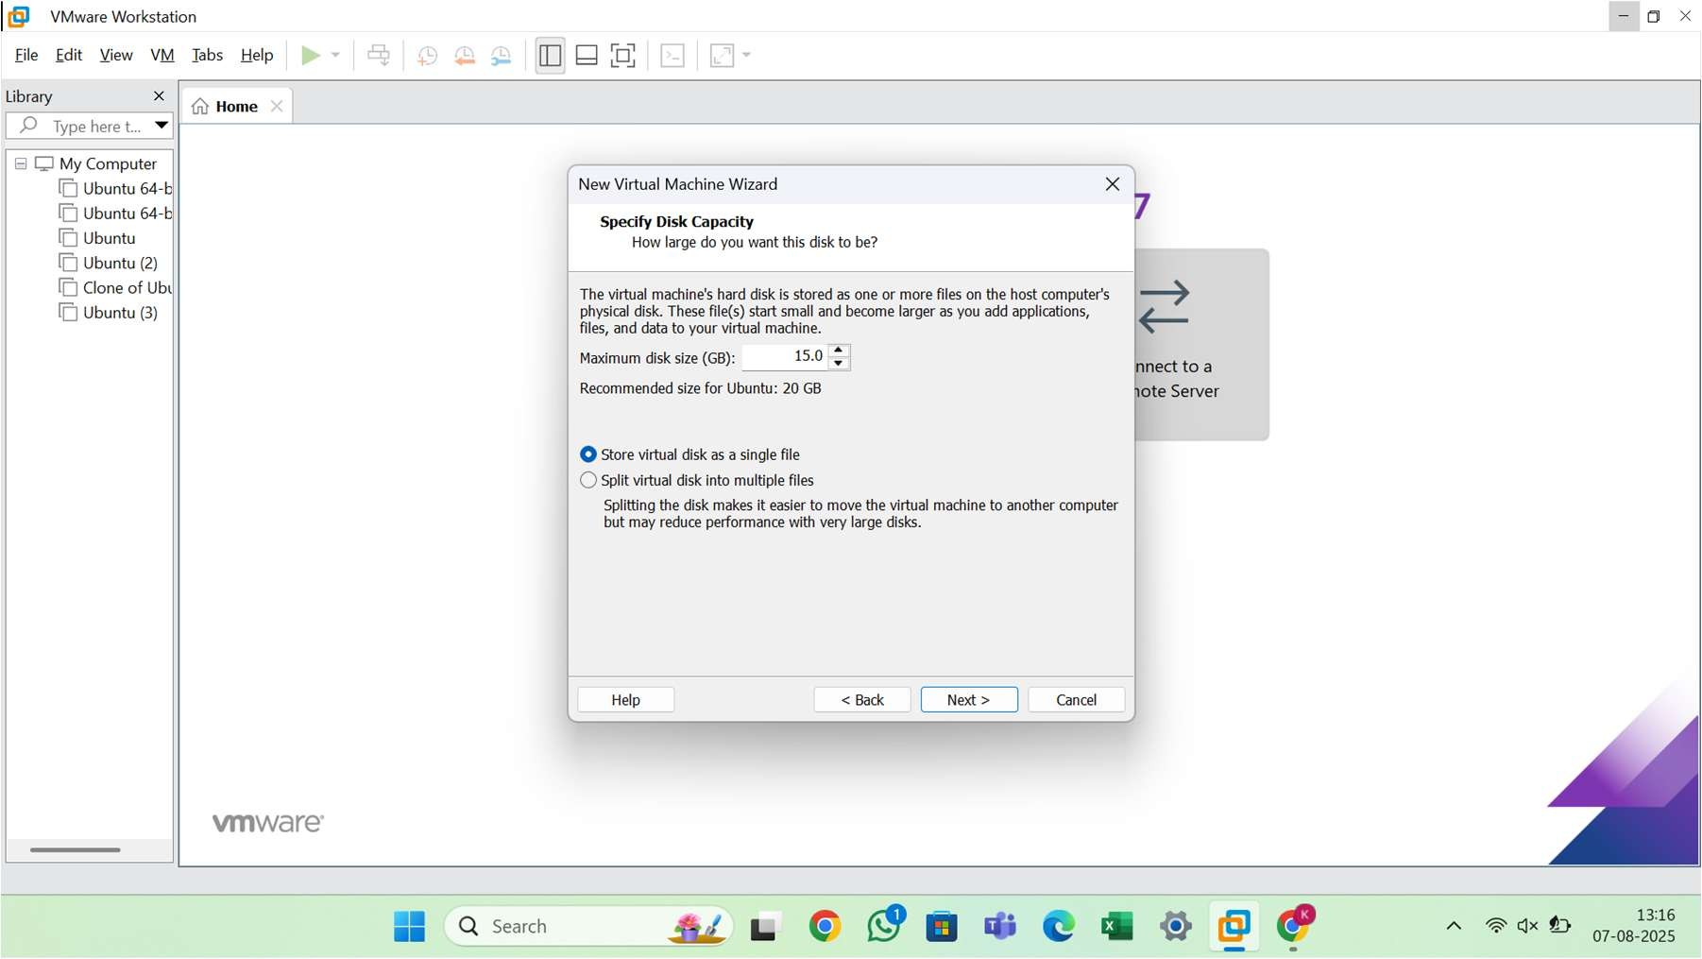

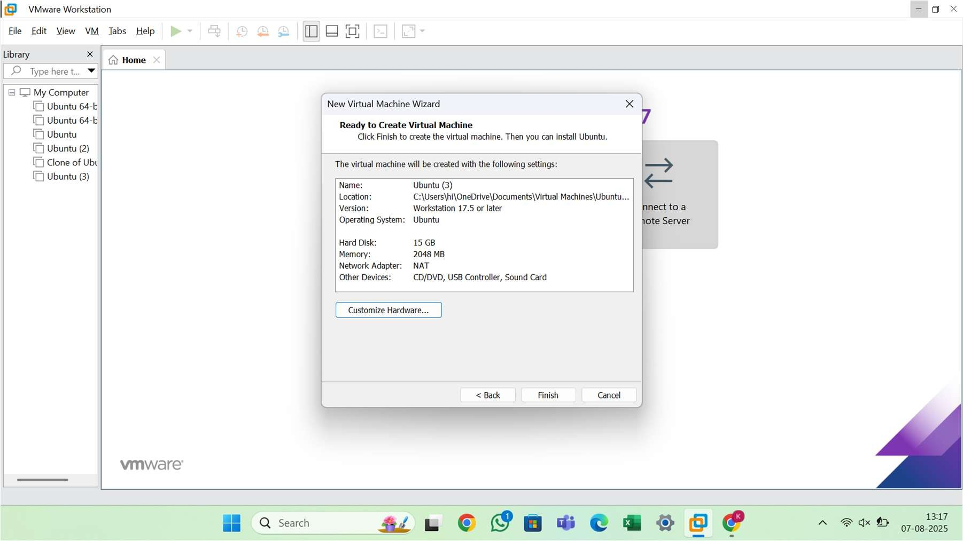

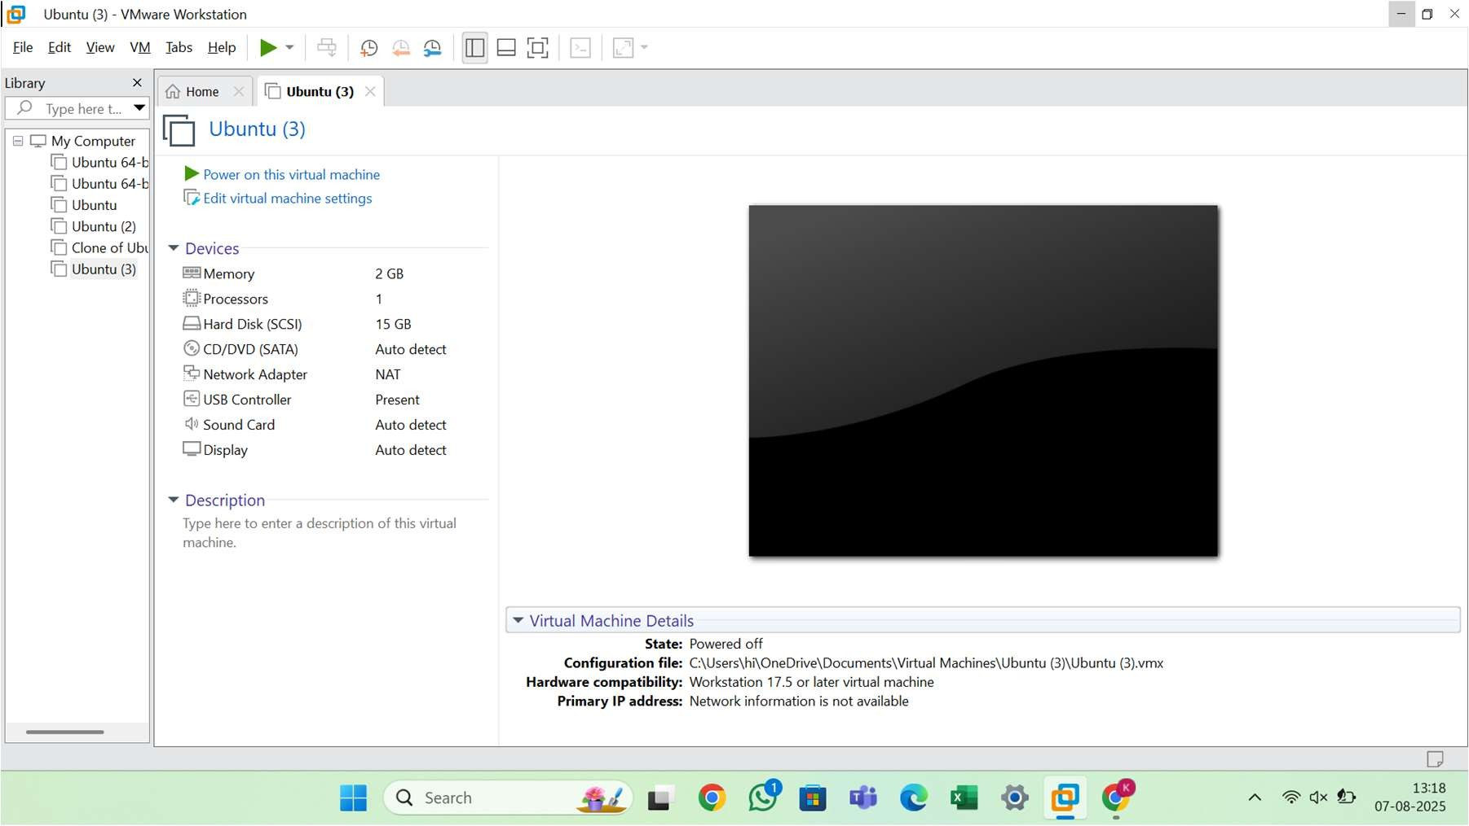


Result
A virtual machine was successfully created using VMware Workstation. The VM is configured with 1 CPU, 2GB RAM, and a 15GB virtual hard disk. The guest operating system was installed and is operational.

VM Hardware Configuration
- CPU: 1 Core
- RAM: 2 GB (2048 MB)
- Storage: 15 GB Virtual Disk
- Network Adapter: NAT or Bridged
- Guest OS: (User-selected ISO, e.g., Ubuntu 22.04 LTS or Windows 10)

